Section 2 – Rubicon / RubiconSL Console Wiring

The Rubicon and RubiconSL consoles are connected to the RIO(s) identically, and they have similar i/o resource requirements and options. Rubicon and RubconSL consoles are typically custom configured for your specific application with the help of SAS engineers. The sample configuration and wiring layout for the RubiconSL console in following section is just one of many ways to configure and wire one of these very flexible console systems; in practice, your setup may be different due to the wide variety of possible I/O card loading, the number of modules (and therefore sources) in your system, and the number of outputs your system uses, including monitor outs, headphone outs, console buss outputs, mix-minus busses, and general purpose outputs.

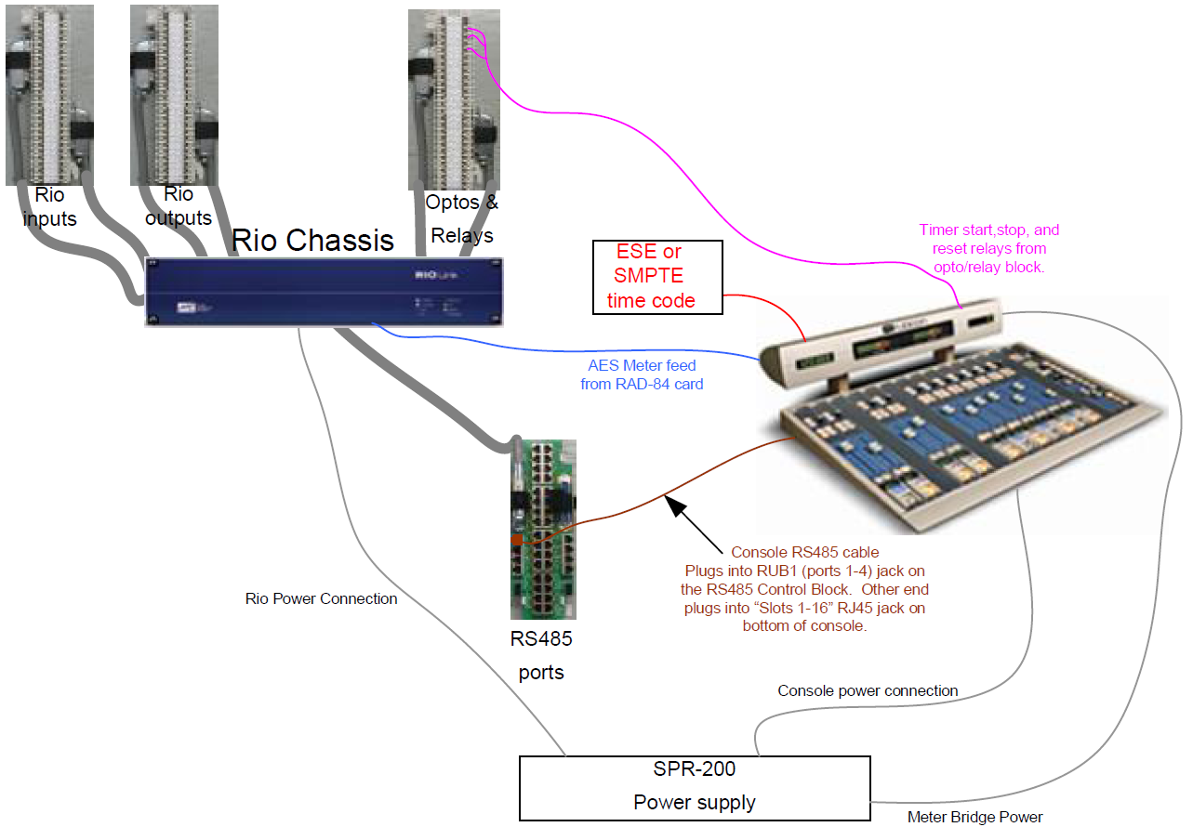
Figure 1. Simplified block diagram for a single-RIO console

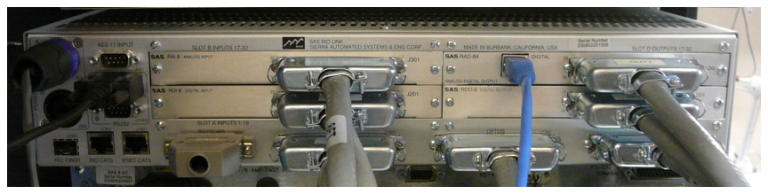

Figure 2. RIO rear panel connections.

The high connection density of the RIO (and 32KD I/O cards) demands an efficient connectorization scheme. RIO audio connections, Optos, Relays, and RS485 control ports are brought out on RJ-21 style (Centronics 50) high-desity connectors. High-quality 25-pair cabling connects the RIO to SAS customized Krone blocks, which also have RJ-21 style connectors. This high-density wiring system maintains Category 5 characteristics all the way to the punch terminals, ensuring maximum performance and noise immunity. One of the benefits of Krone blocks is the built-in patch-bay feature, allowing you to directly patch two connections together if required for bypassing gear or troubleshooting.

Adaptors and patch cables of various lengths are available from ADC/Krone dealers or directly from SAS.

In addition to the Krone blocks, SAS offers RJ-45 wiring options, old-school ‘66' blocks, or direct-wire to the RJ-21 connectors.
Figure 3. Connection blocks
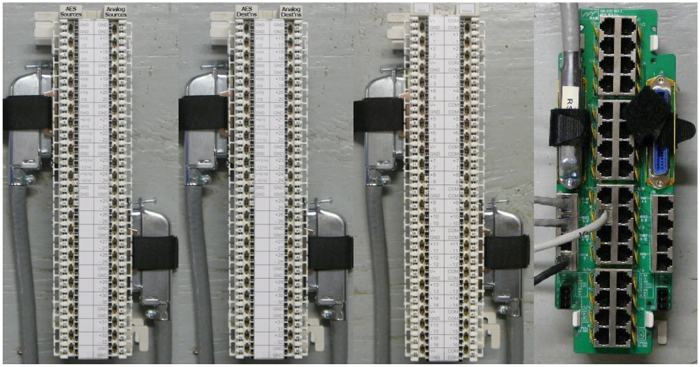
AES and Analog Sources & Destinations Opto/Relay RS485

Each RIO has 7 Centronics-50 pin (Rj-21 style) connectors for audio and control I/O. Supplied cables connect the RIOs to the Krone blocks and 89D2132 block.

Krone Block1:
Audio INPUTS to the RIO. This Audio Source block is where playback devices or other audio sources are connected. Connect the lower input card connector (inputs 1-16) on the RIO rear panel to the left connector on the block; the upper input card connector (inputs 17-32) on the RIO goes to the right connector on the Block. Be sure to cinch down the Velcro strain relief belts so the Centronics connectors are kept tight. In SAS-speak all inputs to the system are called sources. Typically the RIO is set up with half analog and half AES for audio I/O. AES sources 1-16 go on the left; each AES connection represents two mono-equivalent channels which can be configured as stereo or independent mono signals in the system.
The Analog sources, 17-32, connect to the right side of the block. Stereo sources are connected to adjacent channels, left on the lower-numbered odd channel.

Krone Block 2:
The Audio Destinations block is where you connect equipment that requires an audio feed from the console. The layout is the same as the input block; AES on the left, analog on the right. Connect the lower output card connector (outputs 1-16) on the RIO to left connector on the block, and the upper output card connector (outputs 17-32) on the RIO to right connector on the Block. In SAS-speak all outputs from the system are called destinations.
Note that the RAD-84 Analog Output Card on the RIO has 16 (mono equiv.) analog outputs PLUS four auxiliary AES outputs (on the RJ-45 jack) that are copies of the card’s first eight mono outs. These first four stereo outputs on the card are often used dual-duty, for buses and meters.

The RIO has 16 Optos and 16 Relays for interfacing with user equipment logic. The Optos cable connects to the left side of the block and the Relays cable connects to the right side. The Opto side of the block has a +5V logic supply brought out along with ground so you can activate the optos conveniently. The relays are rated at 10W (30V max), perfect for controlling external gear or driving a Solid State relay for your On-Air light circuit.

SAS Consoles and Control Panels communicate with the RIO via RS485. the RIO has 16 RS485 ports. Each port can handle four devices. Each console module is a device, so a 16 slot console connects to the RIO with four RS485 ports. The 89D-2132 Control Fanout Block shown above makes it convenient to connect RS485 ports to your console and other SAS devices. Connect the RS485 connector on RIO1 to the left side of the 89D2132 block. A “line-lump” power supply is available for the 89D-2132 block – If you ordered one, connect it to the power (3 pin phoenix) connection at the lower left corner.

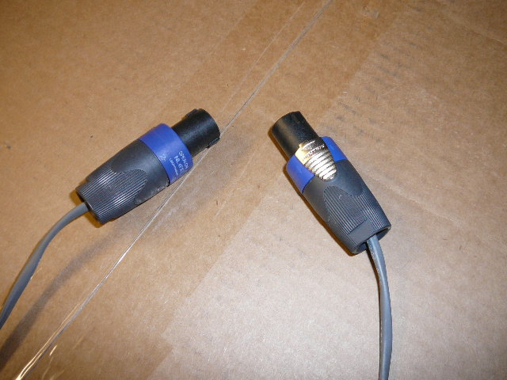
POWER: The typical configuration uses two Rack Mounted power supplies for redundant power to the RIO (or both RIOs in a dual-RIO system), the Console “tub,” and the Meter bridge. The meter bridge uses a smaller connector so a furniture pass-through hole can be hidden by the left meter leg. Your power cabling includes two cables for the meter bridge and four cables for the RIO and console tub. Since each device has two power inputs, you’ll use one power supply to feed the ‘A’ power inputs of each device and the other to feed the ‘B’ power inputs. There’s no priority implied by A & B, just make sure they go to different supplies or you’ll negate the power redundancy feature.
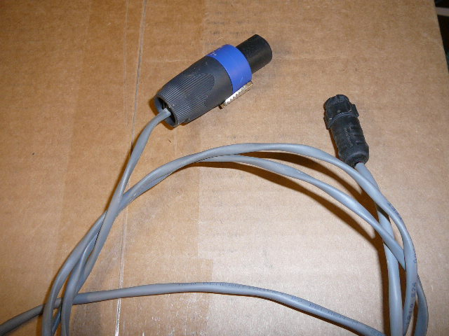
Standard DC Power Cable Meter Bridge Power Cable

Console and Meter Bridge mounting:
Suggested hole patterns for the console tub and the meter bridge are at the end of this wiring guide. The meter bridge comes with two rj45 couplers. One goes on the blue cable (audio feed to meters), and the other goes on the pink cable (timer control).

Audio for driving the meters typically comes from one of two places:
- four AES outputs from a RIO Digital Output Card (RDO). One end of a typical straight-through (TIA568B-style) patch cable plugs into the coupler on the Meter Bridge’s Blue Cat5 cable; the other end of the cat5 patch cable is cut off and the pairs are punched down using the following color code: Wite-Orange/Orange feeds Meter1, Green feeds Meter2, Blue feeds Meter3, and Brown feeds Meter4.
OR
- We often configure the RAD-84 auxiliary Digital Audio Outputs to directly feed the meters. In this case a straight-through (TIA568B-style) patch cable plugs into the coupler on the Meter Bridge’s Blue Cat5 cable; the other end of the cat5 patch cable plugs directly into the RAD-84’s Digital Audio (RJ-45) port.

Timer Start, Stop, and Reset relays (from your RIO) connect to the Orange, Green, and Blue pairs respectively on the Pink Cat5 cable coming from the Meter Bridge.

ESE or SMPTE timecode connects to the Gray single-pair cable from the Meter Bridge.

Check your specific System documentation / Configuration information to determine your specific connections. Contact us if you need assistance.
Other RIO connections:
RIO1 has dedicated outputs designed to feed the (blue cable) meter bridge audio inputs. You may have already connected a Cat5 jumper (straight-through type) to the RAD-84 Digital jack on the lower OUTPUT card of RIO1 – this jumper gets plugged onto the RJ45 coupler on the blue meter-bridge cable.

If your RIO is part of a 32kD system it will connect back to the KRL card in the 32KD mainframe using EITHER a duplex SC fiber connection OR a CAT5 cable. The RIO Fiber transceiver and the RIO CAT5 connections are right next to each other, near the bottom left corner of the RIO as viewed from the back.

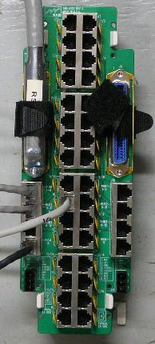
NOTE that the RIO comes from the factory with a Grey-hooded DB25 male plugged into J1502 – this connector has a jumper installed that sets the RIO to match the system clock of 44.1kHz. If your RIO is part of a 32kD system, the RIO’s system clock must match the 32kD system clock setting.

RS485 connections:
Each RS485 port from the RIO supports 4 slots on the console, so a 32 slot console wil require 8 RS485 ports. Specifically the first eight RS485 ports on RIO1. These RS 485 ports are conveniently connected to the console tub using two Straight-thru CAT5 jumpers. The “Slots 1-16” jack on the bottom of the console tub connects to the RJ45 jack labeled “RUBI 1-4” on the left-hand side of the 89D2132 block. The “Slots 17-32” jack on the bottom of the console tub connects to the RJ45 jack labeled “RUBI 5-8” on the left-hand side of the 89D2132 block.

The RS485 port for optional MIC control panels is the 89D-2132 jack labeled “Port 10.” If you’ve connected the power supply to the 89D-2132 block, all you have to do to wire the mic control panels is set the dipswitches for proper addressing and daisy-chain the Port 10
connection to up to four mic control panels.
Additional “turret” panels can be wired similarly to subsequent ports.

The RS485 port for an optional console-mounted intercom panel is provided via CAT5 cable as well. On the bottom of the console, you’ll find an ethercon connector (bulkhead RJ45 jack) labeled AUX – run a cat5 patch-cable from this jack to the 89D-2132 jack
labeled “RICM-16.”

89D-2132 power connection.
DIP switches on MIC control Panels:
The panels used for talent / guest control of the mic positions should be set, in order, to addresses 0,1,2, and 3.
DipSwitch 1 (DS1) on each turret panel sets the addresses and power options for the modules. Switch positions 1 and 2 set the address, 7 and 8 set the pass-thru power mode. 3-6 should be OFF.
Panel pos1, pos2 pos7, pos8
Addr 0 OFF, OFF ON , ON
Addr 1 ON , OFF ON , ON
Addr 2 OFF, ON ON , ON
Addr 3 ON , ON ON , ON

The RS485 cat5 cable connects to the 89D-2132 block as shown above, and is connected in a daisy-chain fashion to up to three more panels. If you have more than four panels, contact us for additional features of this wiring scheme that you can use to make the installation job a snap.

Sample RIO Configuration Data (be sure to use YOUR data for installation.
Audio Sources feeding inputs of the Router/RIO.
Figure 4. Source Data
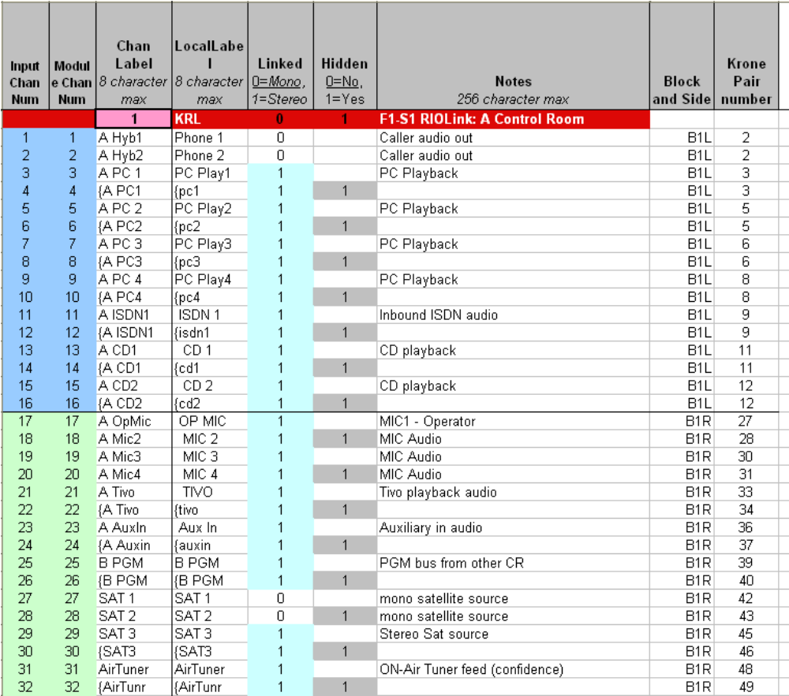

Source Channels 1-16 are AES inputs to the system, eight stereo or dual-mono AES sources – Channels 17-32 are analog inputs to the system, usually a mix of mono and stereo sources.
Note that stereo resources must be on sequential channels with left on an odd channel number and right on the next (even) channel number.

The Krone blocks have numbered pairs from 1-25 on the left side of the block and 26-50 on the right. The block side and pair numbers for each source are included in the chart above.

For Example, the AES connection for inbound ISDN audio is on inputs 11/12, which is punched down to Audio Block 1 (inputs) Left side, on the ninth pair of the block.

The analog connection for MIC 3 (a mono, line-level input from a pre-amp) is connected to Audio Block 1 Right side, on the fifth pair of the block.

Figure 5. Destination Data
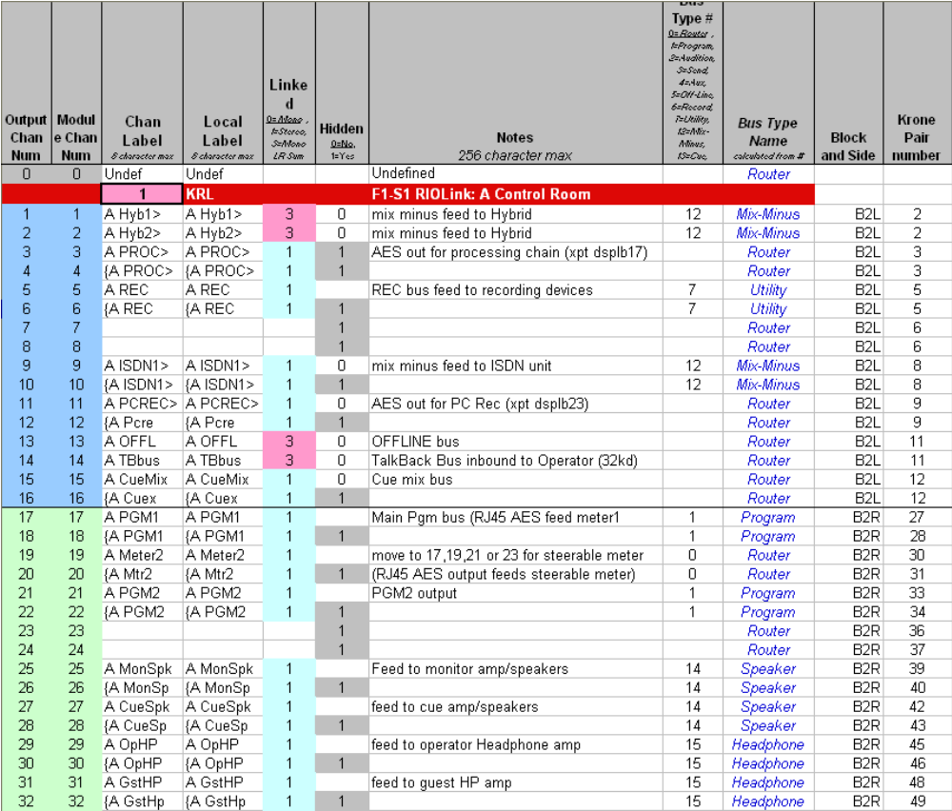

Destination Channels 1-16 are AES outputs from the system (eight stereo or dual mono AES outs) – Channels 17-32 are analog outputs from the system.

The Krone blocks have numbered pairs from 1-25 on the left side of the block and 26-50 on the right. The block side and pair numbers for each destination are included in the chart above.

For Example, the AES connection for outbound PC Record audio is on outputs 11/12, which is punched down to Block 2 (outputs) Left side, on the ninth pair of the block.

The analog connection for the cue speaker amp is connected to Block 2 Right side, on pairs 42 and 43, which are the seventeenth and eighteenth pairs on the right side of the block of the block for left and right respectively.

