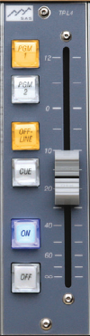
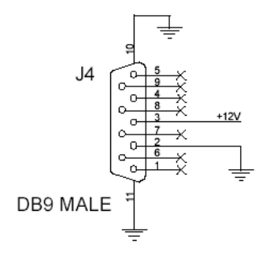
TPL-4 modules install much like other SAS control panels, using an RS485 port from your system, and a 12V DC power supply.

Power is typically wired to the unit’s D-Sub 9 connector (male on the TPL-4, so your power supply will have a female) on pins 2 and 3. 2 is ground and 3 is +12. SAS can provide regulated 12V supplies with multiple, pre-wired, nine pin females that can power several TPL4s.

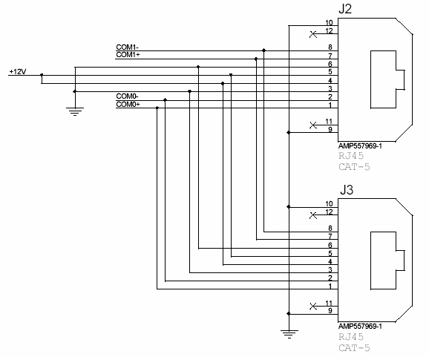
Power can optionally be wired using the RJ45 connectors. These two connectors are in parallel and carry +12V power and RS-485 bus signals. Typically, when several TPL-4 modules are grouped together (as in a Turret or Rubi-T installation) one of the RJ-45 connectors is used to daisy chain to the next module, providing power and RS-485. Up to four TPL-4 modules can share one RS-485 port. Up to eight TPL-4 modules can be powered by the SAS 12V 3A regulated supply.

Apply +12 volts DC using ONLY ONE of J2, J3, or J4.
+12 volts DC and Power ground is always present at J2 & J3 (pins 3-6), even if J4 is used to supply the power.

Com0 (pins 1 & 2 – typically the orange pair on a standard 568B-wired patch cable) is the RS485 bus used by the TPL-4; Com1 (pins 7 & 8 – 568B brown pair) is unused by the TPL-4, but can be useful for wiring convenience if daisy chaining more than four TPL-4s. It can “carry” a second RS-485 port through the first four modules, using the common daisy-chained wiring. Between the fourth and fifth units, the first RS-485 bus is abandoned and the second RS-485 port is crossed over to the Com0 wires for the next four modules.
Configuration of your TPL-4 modules is done in the Router Control Software.
Start out in the Switcher Status/Configuration folder. Click Config for the DRC or RIO/KRL module that you’ve wired the TPL-4 RS-485 connections to. If you’ve wired the RS-485 to a RIO, click on the KRL for that RIO then select the (middle) Control Module Config tab.
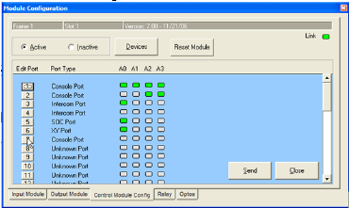
Click on the numbered rectangle for the port you wired the TPL-4 to.
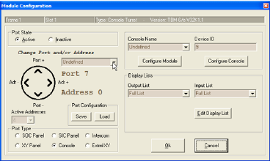
Set the Port State to Active; Set the Port Type to Console, and click OK. Click SEND.
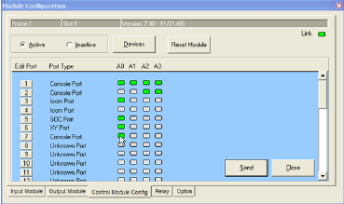
You should now see a Green dot for any active addresses on the RS-485 port.
Click on the rectangle port number again to go back to RS-485 Module Configuration.
The module type should show up as an SL INPUT. Note the Port and Address control. If you have more than one TP-L4 connected to this RS485 port, you can toggle between them using the Adr+ and Adr- (left and right) arrows. If you want to configure modules on other physical RS485 ports (for the same RIO or DRC), you can change ports with the Port + and Port – (Up and Down) arrows.
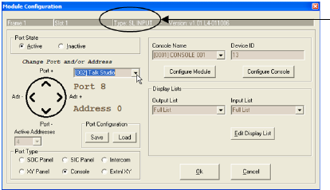
Make sure you are looking at the correct port and address for your new panel, then set the Location of the panel (highlighted above).

Next, associate the module with a console. This can be an existing full-size console (basically adding another input module to an existing Rubicon or RubiconSL console) or a new or existing Rubi-T console.

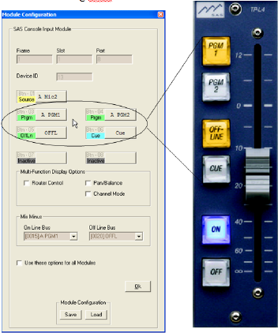
Click Configure Module.
The SL Input Module configuration tab opens up. The TP-L4 has four programmable buttons. The bottom two buttons are set to be the On and Off buttons – just like on a “normal” Rubicon or RubiconSL input module.

The upper four buttons on the TP-L4 module are represented by buttons three through six on the Input Module Configuration Tab.

These buttons can be set up just like the buttons on full-size input modules. Typically the TP-L4 buttons are used to assign the default source (see below) to various console buses. Please read the Bus Topology section below and understand how TP-L4 modules interact with existing consoles before you set up bus assigns.

Button one on the Input Module Configuration screen is where you can set a default source for the TP-L4 module. If none of your programmable buttons will be used as source select buttons – you must assign the module’s source. To do this click button one, set the button type to Source Select, and select the source that this module will control.

Button one can be left blank (undefined) if any programmable buttons on the TP-L4 (buttons 3-6 on the Input Module Configuration screen) are set to be source selects.

Once your buttons (and optionally the default source) are programmed the way you want them, set the Mix Minus options for the module if required (if controlling a source that gets a mix-minus return feed).

Click OK on the Input Module Configuration screen. Now that you have programmed the module on address 0; if you have other TP-L4 modules to set up, you can change addresses and/or ports as needed using the Port and Address control arrows and program others. When you are finished programming modules (or just want to “save” your progress to try out what you’ve done) click ok on the RS485 Module Configuration screen and click SEND on the KRL/RIO or DRC Module Config screen.

Bus Topology:
The TP-L4 modules can act as extensions to existing full-size consoles (basically adding another input module to an existing Rubicon or RubiconSL console) or can be part of a new or existing Rubi-T console. The Rubi-T console has its own buses, creates its own mix minuses, and behaves independently of other consoles. These Rubi-T buses behave just like other console buses. They are developed on system (RIO or 32kd) outputs and can also be seen elsewhere as SOURCES if the DSP Loopback source is available to the other destination or console.

When set up as an independent console (Rubi-T): Just like selecting the same source on two different Rubicon or RubiconSL consoles … If you assign (or select) a source to control with your TP-L4 that can also be selected on another console, keep in mind that the last one to select the source has control over the any mix-minuses associated with the source. This can make for abrupt changes in what’s feeding a mix-minus device if it is selected in Studio B while the source is actively being used in Studio A.

When set up as an auxiliary input module for an existing console:
A source can only be assigned to an output bus by one module at a time. So if you have a source that you want to control in the main control room OR on a talent turret elsewhere – the source must be deselected on all other modules of the console (actual console modules and TP-L4 modules alike) before you can select it / assign it to a bus on any other input module (including the TP-L4) on the same console. Since there is no way to deselect a default source (one assigned using the RCS instead of selected by pressing a source select button) on the TP-L4, we recommend that you set up A source and B source buttons for TP-L4s used in this manner. The A source can be the source that you want to be able to control from either location, while the B source can be another source or a dummy source; you can even use a non-existent source number, just be sure it doesn’t exceed the number range used on your system and that it doesn’t reference a virtual (DSP Loopback) source derived from one of your existing outputs. If the talent in the talk studio wants to control the on/off and levels on his microphone, it must be deselected on its usual module in the control room before the talent can control it with the TP-L4. Similarly when you want to return control of that microphone to the operator in the control room, the TP-L4 must not have the source selected (push the B – dummy source – button to deselect it) for the control room operator to gain control of it.

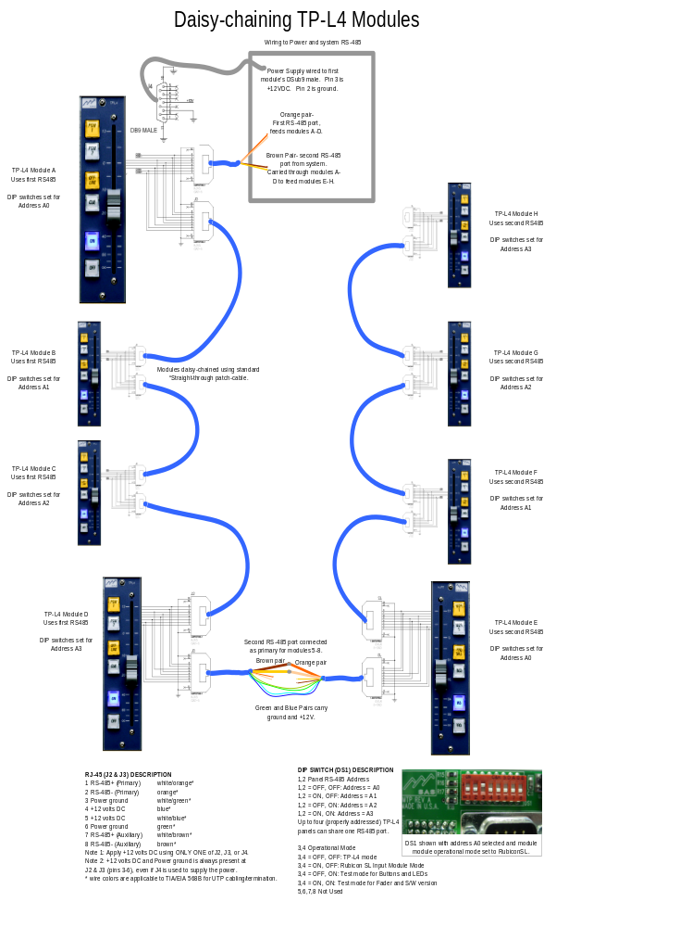

TP-L4 Connector Pin Out:

9-PIN D (J4) DESCRIPTION
1 N.C.

2 Power ground
3 +12 volts DC
4 N.C.
5 N.C.
6 N.C.
7 N.C.
8 N.C.
9 N.C.

RJ-45 (J2 & J3) DESCRIPTION

1 RS-485+ (Primary)
2 RS-485- (Primary)

3 Power ground
4 +12 volts DC
5 +12 volts DC

6 Power ground
7 RS-485+ (Auxiliary)
8 RS-485- (Auxiliary)

Note 1: Apply +12 volts DC using ONLY ONE of J2, J3, or J4.
Note 2: +12 volts DC and Power ground is always present at J2 & J3 (pins 3-6), even if J4 is used to supply the power.

SWITCH (DS1) DESCRIPTION
1,2 Panel Address
1,2 = OFF, OFF: Address = A0
1,2 = ON, OFF: Address = A1
1,2 = OFF, ON: Address = A2
1,2 = ON, ON: Address = A3
Up to four (properly addressed) TP-L4 panels can share one RS485 port.

3,4 Operational Mode
3,4 = OFF, OFF: No Function currently
3,4 = ON, OFF: Rubicon SL Input Module Mode
3,4 = OFF, ON: Test mode for Buttons and LEDs
3,4 = ON, ON: Test mode for Fader and S/W version

5,6,7,8 Not Used

