

**SAS MCU-64 Frame Controller Module**

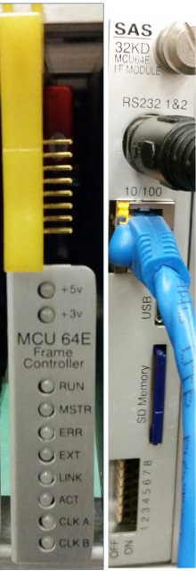

**User Guide**

Table of Contents

Preface 3

Overview 4

Dual MCU Operation 4

Polling Operations 4

Clock Master 5

Front Panel 6

Rear Panel 7

Web Browser Support 8

Installation 8

Ethernet 8

Advanced Control 9

Sync a New MCU to In Service MCU: 9

Stop Acting as Bus Master/ Switch Poll-Master to another module: 10

Save Mainframe System Operational Database To SD and Restore From SD: 10

Network Configuration 11

System Information 11

Router Control: 12

Frame Configuration: 12

Crosspoint Map: 12

Input Channel Config: 13

Output Channel Config: 13

RS232 Serial Ports 14

Appendix A: Support and Limited Warranty 15

**Table of Figures**

Figure 1: MCU-64 Front Panel 6

Figure 2: MCU-64 Rear Adapter 7

Figure 3: SYSCFG File 8

Figure 4: Web Interface Access 8

Figure 5: Webserver Home 9

Figure 6: Advanced Control Screen 9

Figure 7: Stop Acting as Bus Master Screen 10

Figure 8: Save To SD and Restore From SD Screen 10

Figure 9: Network Config Screen 11

Figure 10: System Information Screen 11

Figure 11: Router Control >> Frame Configuration Screen 12

Figure 12: Crosspoint Map Screen 12

Figure 13: Input Channel Config Screen 13

Figure 14: Output Channel Config Screen 13

# Preface

Thank you for purchasing an SAS product. We are confident it will meet your requirements and provide years of service. Please check this module and make sure it is the model you ordered. If you need to contact us, please refer to Appendix A: Support and Limited Warranty.

**Proprietary Notice**

This document contains proprietary information, which may not be disclosed to others or used in manufacturing, or any other purpose, without written permission from Sierra Automated Systems & Engineering Corporation. The information and design disclosed herein were originated by and are the property of Sierra Automated Systems & Engineering Corporation. All patent, proprietary design, manufacturing, reproduction, use and sales rights are reserved except where those rights are expressly granted to others.

**Copyright Notice**

Copyright 2015 by Sierra Automated Systems & Engineering Corporation, Burbank, California, USA. All rights reserved. Reproduction in whole or in part without prior written permission from Sierra Automated Systems & Engineering Corporation is prohibited.

**Limited Warranty**

This product MCU-64 of Sierra Automated Systems & Engineering Corporation (SAS) is warranted to be free from defects in materials and workmanship for a period of three years from the date of sale (see Support and Other Information for details.)

**User Guide Revision**

This MCU-64 User Guide is published by the Engineering Department of Sierra Automated Systems & Engineering Corporation, which is responsible for its contents. SAS reserves the right to revise this publication and to make changes in the content hereof without obligation to notify any person or organization of such revisions or changes

# Overview

The MCU-64E Frame Controller Module provides you with direct Ethernet connectivity. You can now control your SAS 32KD system using an internet web browser interface while maintaining compatibility with the traditional SAS Router Control Software (RCS). The MCU-64E allows you optimum system response times, even under the most demanding communication loads. Furthermore, the MCU-64E lets you instantly backup and restore your frame configuration through an SD memory card (supplied).

There are two ways of communicating with your SAS 32KD System when using the MCU-64E module:   
Ethernet connectivity through a 10/100 RJ45 connector or through an RS-232 serial port. Even the traditional SAS Server Module software can communicate with blazing speed through the Ethernet port. You just need to set the connection type to TCP/IP instead of RS-232 serial. External automation and delivery systems can also take advantage of the direct Ethernet connectivity.

The MCU-64E can co-exist with either another MCU-64 or an MCU-32 frame controller module to provide your 32KD system with redundant control and clock source. As we explain below, note that the ability to have Dual MCU Operation, where each frame controller backs each other up, is an important feature of the SAS 32KD system.

## Dual MCU Operation

A significant advantage in the 32KD System is that you can use Dual MCU Frame Controllers in each mainframe. These frame controllers keep each other up to date so you can remove or update one while the other carries administering mainframe operations. Another advantage is the ability to have two control systems, a Primary and a Secondary. If you use two computers and have a failure with one of them, the other will be available to provide an interface for status and control – a ‘window’ into the system health and operation.

It is important to understand the rules applied to Dual MCU 32KD Mainframe polling operations. It is also important to understand the rules which determine 32KD Mainframe Clock Master.

### Polling Operations

The 32KD mainframe houses 21 module slots. Internal mainframe communication is orchestrated by one of the MCU Frame Controllers. The mainframe communications is poll-response, where the Master or Primary MCU is polling all active slots. Each participant responds immediately after being polled. The Backup or Secondary MCU is simply listening to all communications and keeps all data in sync with the Master or Primary MCU. The Backup MCU also responds to polls from the Master MCU, giving it a time to respond and ‘speak’ to the mainframe. Note that the Backup MCU is able to issue commands to the backplane during its allotted time to speak. Thus, it can provide complete Control and Status to SAS Server / Router Control Software and SAS PC Automation.

However, note that the Backup MCU is not able to provide a path for System Configuration. *This means that you cannot change Alphas, Channel Configuration, Port and Console Programming or MCU (built-in) Automation using Router Control Software (RCS) when connected to the Backup MCU*. If the Master MCU ever stops polling or ‘goes away’, the Backup MCU will initiate polling and will become the Master controller. At this point the Master LED on the front panel will illuminate indicating that this MCU is now the acting Master (see Figure 1, item 4). When the other MCU is returned to service it will join the system as the Backup MCU (i.e. not the poll-master), only resuming Master operation if it senses that the mainframe is not being polled.

From an operational perspective, it does not matter which MCU is operating as the Poll or Bus Master unless you, the engineer, want to program changes to the System Configuration. In order to change system configuration you must communicate through the acting Master MCU. *Always check the Master LED indicator on the front panel of the MCU to ensure it is the current acting Master before attempting to program changes to the configuration or built-in automation.* While the system is running you can change which MCU will operate as Master. This is accomplished by commanding the active poll Master to Stop Polling. Please refer to the section **Stop Acting as Bus Master** and Figure 7. The Master will stop polling and extinguish the front panel Master indicator light. The Backup MCU will pick up polling duties once it senses that the poll master has stopped and will become the Master.

Your MCU Frame Controller has a ‘dipswitch’ or ‘strap’ to set it up as either Master or Backup MCU upon wake up (see Figure 2, item 5). *Note that this preference is only valid at power up*. Thus, if the mainframe is powered up from a ‘cold start’, such as after a power failure, the MCU(s) in the mainframe will use this information to determine who will act as the poll Master. The MCU which is strapped/switched to be a Backup will wait 10 seconds for the Master MCU to start polling and administrating the mainframe. If the Master does not ‘come on line’ the Backup, assuming the Master is not present or has been commanded to give up polling, will pick up polling duties and become the Master MCU.

An interesting application to be considered is the ability to run dual **SAS PC Automation**: if you use SAS PC Automation you can run the automation engine through the acting Master or primary MCU. If you command this MCU to give up the Master polling status to another MCU it will still continue to perform the PC Automation tasks. Thus, if this MCU is removed for service or is going to receive updated firmware you can start the ‘backup’ PC Automation engine and it will function through the MCU to which it is connected. If the two computers are synchronized to the same clock (e.g. network time) you can actually run both PC Automation engines at the same time. Each Automation engine will enter the system through different MCUs. *Note that all commands will be executed twice!* This isn’t a problem for a crosspoint Take command (connection command) but may cause an issue if an opto trigger or relay are commanded to pulse twice. If you are considering running two Automation engines simultaneously, please examine and evaluate the automation events to ensure that ‘double’ execution will not cause unintended consequences.

### Clock Master

In your SAS 32KD System there is only one clock provider at any time during operation. Note that the MCU Polling Master status is totally independent of clock. Modules which are capable of providing clock are **MCU Frame Controllers and ANI Audio Network Interfaces**. These modules have very high accuracy and stability clock generators on board. There are two internal busses in the mainframe, A and B. Each bus is independently driven from the clock master module. The system can optionally be fed with an AES11 master clock source on the rear of the mainframe if you require sync to other systems in the facility. Many facilities do not use a master clock generator, but rely on the high quality clocks of the SAS 32KD to provide master clock. The 32KD inputs are all equipped with sample rate convertors to accept any rate of digital input.

When a mainframe is powered on, the MCU in Slot 21 is most likely to assume clock duties and provide master clock. The ideal location for your Primary MCU (either MCU-32E or -64E) in the 32KD Mainframe is Slot 21. This location provides for the fastest wake up and works great for master clock too. Slot 20 is a great location for an SAS ANI-2500 Audio Network Interface module. The mainframe clock will be handed off to an ANI module if the module is recovering clock which is distributed over the ANI Network. This is a coordinated handoff between the module which is driving clock at power up (likely the MCU in Slot 21) and the ANI module. When adding a second MCU module to a system, Slot 19 provides a great location for the second MCU, leaving the ANI module in Slot 20. Slot 20 also works great for a second MCU in a single frame system.

## Front Panel

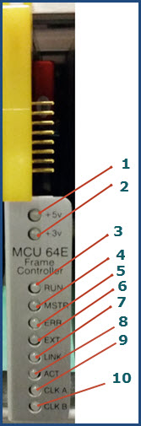

Figure 1: MCU-64 Front Panel

1. +5v indicator should be solid blue.
2. +3v indicator should be solid blue.
3. Run light should be blinking green at a regular rate.
4. Master light will be solid green if MCU-64 is the Primary frame controller. Otherwise the light is off.
5. Error light will briefly flash red if an error is encountered.
6. External light will be on green if an external AES-11 sync connection is attached, otherwise the light is off
7. Link light will be on green if a valid ethernet connection is detected.
8. Activity light will blink green to indicate ethernet communications activity.
9. * Clock A light will be solid green if the MCU-64 is providing system clock on clock bus A.
10. * Clock B light will be solid green if the MCU-64 is providing system clock on clock bus B.

* A and B clock busses provide an additional level of fault tolerance. If the integrity of the clock bus is uncertain, each frame controller module will automatically switch to the alternate clock bus.

## Rear Panel

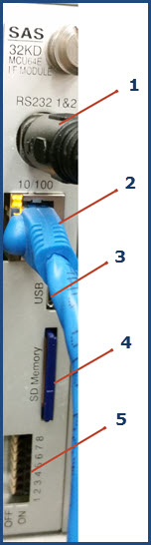

Figure 2: MCU-64 Rear Adapter

1. RS232 connectorprovides two RS-232 serial ports through supplied cable adapter. Use Port A for serial connection of the Admin computer running the SAS Router Control Software. ***Note****: Port B is reserved for future development.*
2. Ethernet connector 10/100 MB for connection to SAS Server Module Router Control or for switcher control by external computer systems via the published SAS USI protocol.
3. USB connector (currently not activated).
4. SD card for saving and restoring frame system data and specifying initial IP address information.
5. DIP switch provides 8 switches for configuring Frame Address, and Master/Backup mode.

Switch Description

1 Switches 1-5 indicate Frame address (switch off is a zero)

2 Binary count to indicate Frame # All switches OFF is Frame 1

3

4

5

6 Power Up Preference to Operate as a Backup module (switch On is Yes)

7 Unused / Future

8 Unused / Future

|  |  |  |  |  |  |
| --- | --- | --- | --- | --- | --- |
| Frame # | SW1 | SW2 | SW3 | SW4 | SW5 |
| 1 | 0 | 0 | 0 | 0 | 0 |
| 2 | 1 | 0 | 0 | 0 | 0 |
| 3 | 0 | 1 | 0 | 0 | 0 |
| 4 | 1 | 1 | 0 | 0 | 0 |
| 5 | 0 | 0 | 1 | 0 | 0 |
| 6 | 1 | 0 | 1 | 0 | 0 |
| 7 | 0 | 1 | 1 | 0 | 0 |
| 8 | 1 | 1 | 1 | 0 | 0 |
| 9 | 0 | 0 | 0 | 1 | 0 |
| 10 | 1 | 0 | 0 | 1 | 0 |
| 11 | 0 | 1 | 0 | 1 | 0 |
| 12 | 1 | 1 | 0 | 1 | 0 |

## Web Browser Support

Web browsers currently tested compatible are:

1. Microsoft Internet Explorer, version 11

2. Google Chrome, version 41.xx

3. Firefox, version 21.xx

4. Safari, version 5.1.7

# Installation

You have two options for interfacing with the SAS MCU-64E module: Ethernet or RS232 serial connection.

Ethernet: Before you apply power to the MCU-64 Module you need to set up the proper IP address.   
***Note****: you will need an SD card reader/writer and computer for this procedure.*

1. Remove SD card and insert into a reader. Open folder to view files and open SYSCFG.TXT

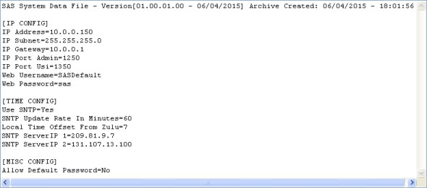

Figure 3: SYSCFG File

1. Modify the IP address and other parameters as needed to work with your IP network and save the file.
2. Install the SD card into the MCU-64 rear adapter and restart the MCU-64 if changes were made. The IP address is only established at Power Up.
3. When Power is applied to the MCU-64 both blue Power lights will come on and the Run light should blink green.
4. Using your web browser, connect to the MCU-64 at the configured IP address and enter the default Username and Password as shown below. You can change these later.

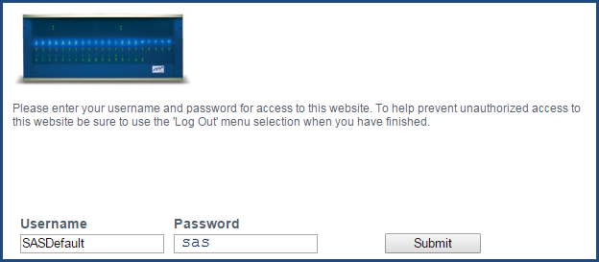

Figure 4: Web Interface Access

1. You should see the Web Server Home screen below

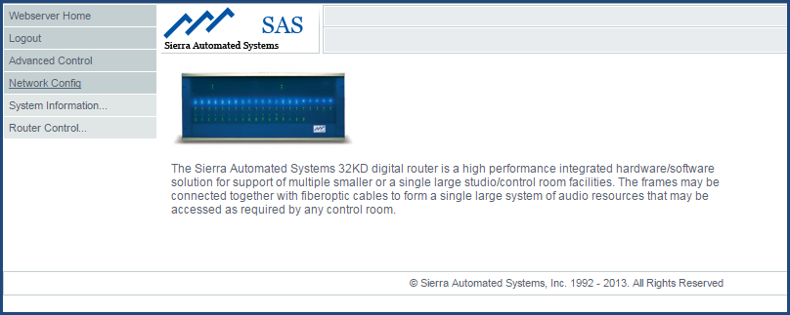

Figure 5: Webserver Home

### Advanced Control

Under the Advanced Control tab (see Figure 6) you can execute the following commands. You can hover over each button on any screen for a help tip.

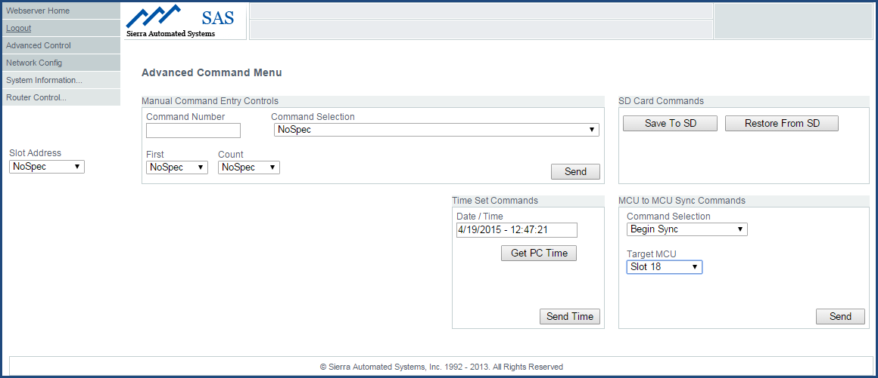

Figure 6: Advanced Control Screen

#### Sync a New MCU to In Service MCU:

Use this command when you have first installed a Backup or Secondary MCU-64E or MCU-32 module. See Figure 6 above, lower right corner, under MCU to MCU Sync Commands. This command allows you to synchronize the data in the new module to the MCU Master or primary module which is in service. It is important to sync the new module so it has a complete database and an accurate view of the status. After the initial sync process is complete the new module will stay up to date by listening to all data communications within the mainframe. Make sure that the Target MCU slot address is the new module! For the example above, if the new MCU is placed in Slot 18, ensure the Target MCU is set to Slot 18. Click Send button to execute command.

#### Stop Acting as Bus Master/ Switch Poll-Master to another module:

Use this command to swap frame controller Master status and operation. In Figure 7 below, we are stopping slot 21 from acting as the Bus Master. In this example we have an MCU-32 in slot 21 and an MCU-64 in slot 18 (See Figure 13 for Frame Configuration). Select Command (020), Instruct MCU to stop acting as Bus Master’, set the Slot Address (to Slot 21) and click the Send button: the MCU-32 in slot 21 will cease polling. The MCU-64 in slot 18 will recognize that the polling master has stopped and it will become the Poll-Master and start polling. This action also, by definition, means that the MCU in slot 21 will become the Secondary / Slave MCU. As discussed previously, the Slave can still provide all status and connection control – just no configuration programming.

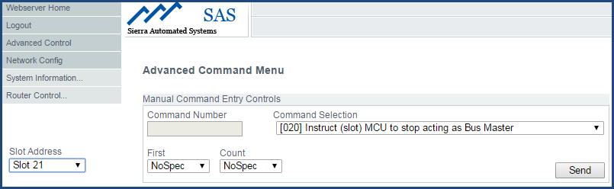

Figure 7: Stop Acting as Bus Master Screen

#### Save Mainframe System Operational Database To SD and Restore From SD:

To Save the System Configuration data to the SD memory card, set the Slot Address to the module you are working with, then Click on Save To SD button. Only one image is saved on an SD card. You can create multiple cards by copying SYSCFG.txt for this MCU module to another card.

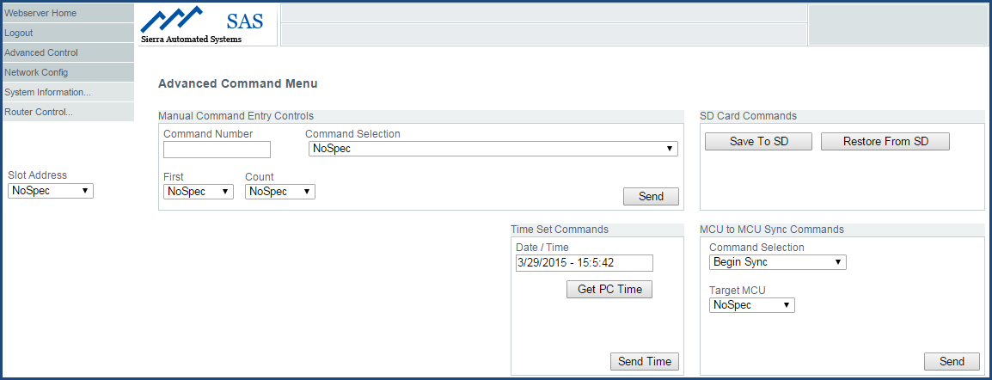

Figure 8: Save To SD and Restore From SD Screen

### Network Configuration

Click this tab to review or change Ethernet configuration and Username or Password. See Figure 11 below. Note that you can hover over each button on any screen for a help tip.

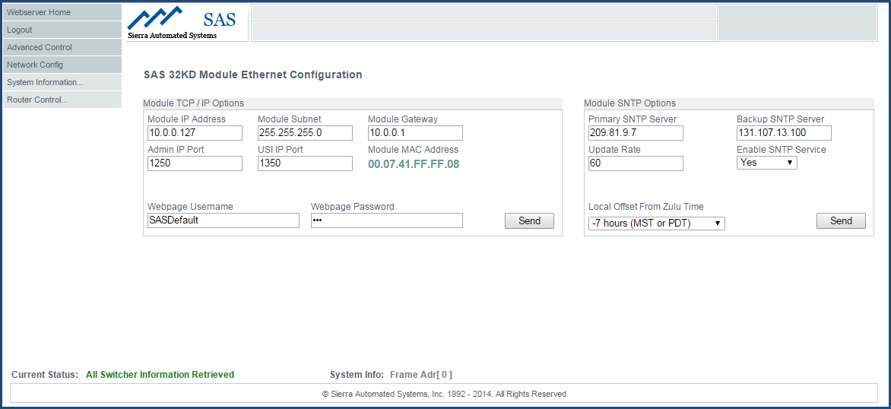

Figure 9: Network Config Screen

System Information

Press this tab to review, refresh, or clear system operating logs, error logs or system init logs. If the SAS Admin computer is connected and running the SAS Server module, this information is also available in text files created in the SAS Server module installation folder. This web page displays the last 512 items in those logs.

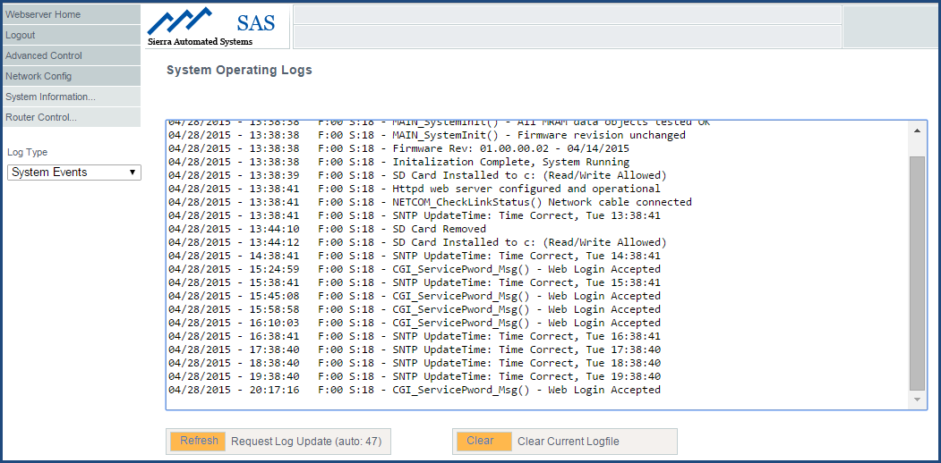

Figure 10: System Information Screen

### Router Control:

There are four selections under Router Control tab: Frame Configuration, Crosspoint Map, Input Channel Config and Output Channel Config. Please remember to hover over each button on any screen for a help tip.

#### Frame Configuration:

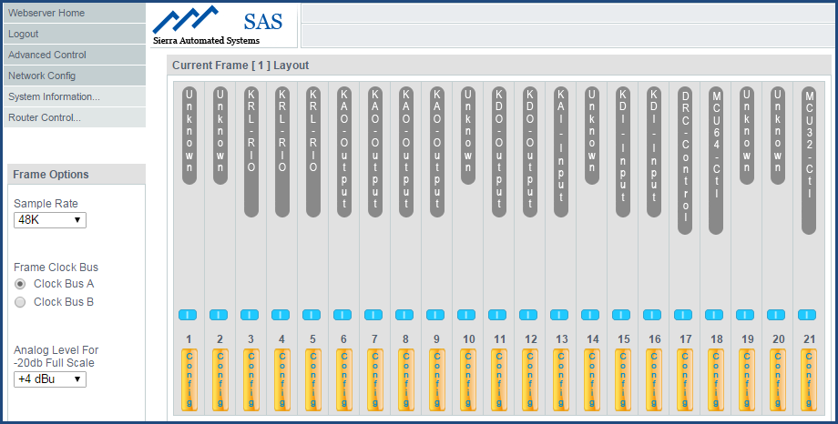

Figure 11: Router Control >> Frame Configuration Screen

#### Crosspoint Map:

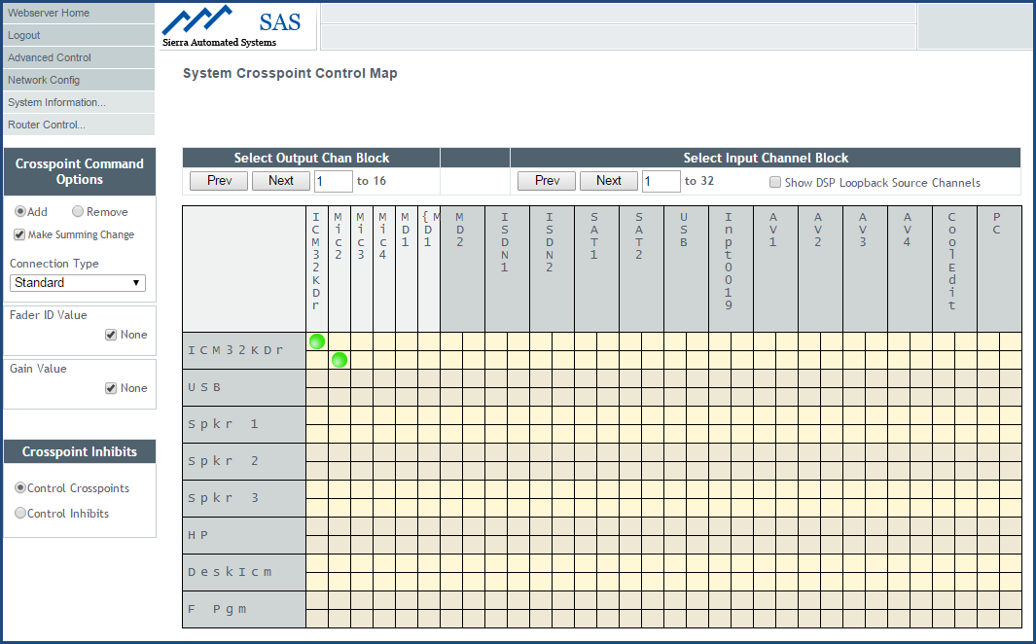

Figure 12: Crosspoint Map Screen

#### Input Channel Config:

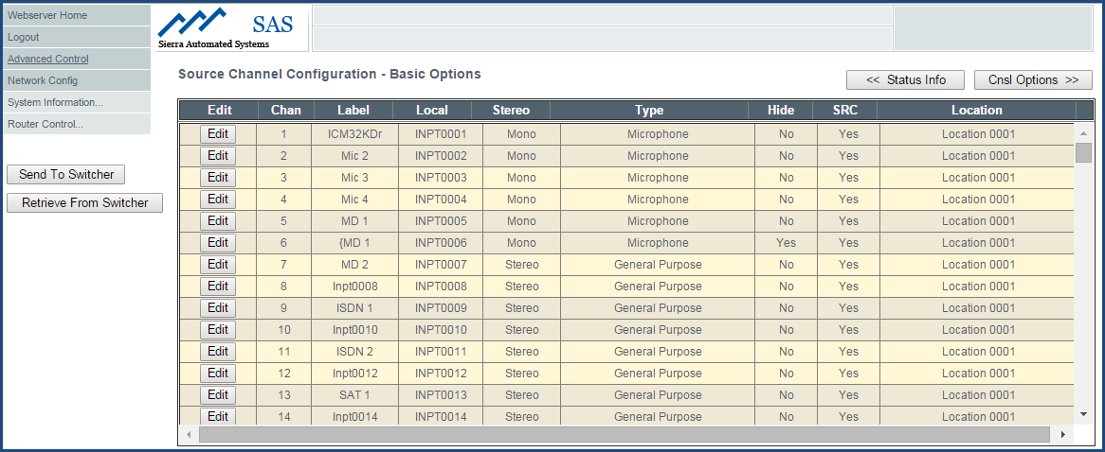

Figure 13: Input Channel Config Screen

#### Output Channel Config:

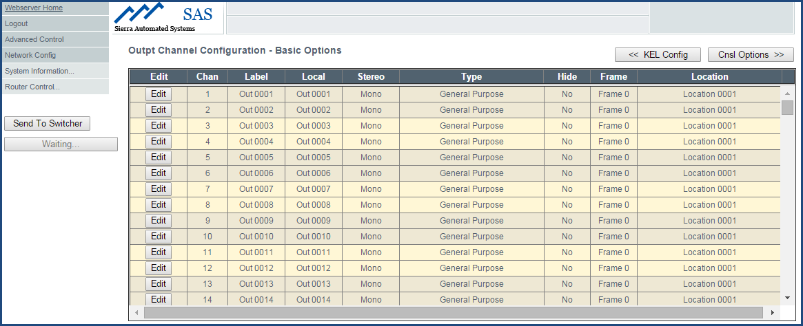

Figure 14: Output Channel Config Screen

RS232 Serial Ports

You can also connect the MCU-64 to the SAS Admin computer using serial port A (serial port B is reserved for future development). You can use the cable adapter provided with two DB9 connectors wired to pin 2 for Transmit (Tx), Pin 3 for Receive (Rx), and pin 5 for RS232 ground.

1. If the server module is running on your administrator PC, you should see the screen below

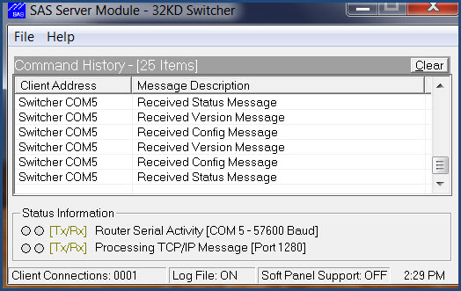

1. If the router control module is running on your administrator PC, you should see the screen below

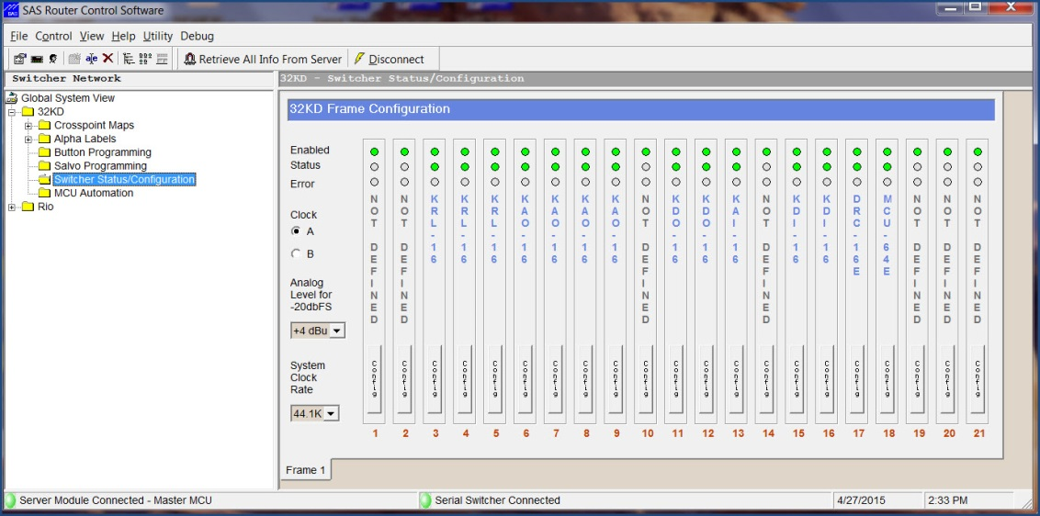

Once the MCU-64 is connected successfully you can use your RCS interface to program and configure your system.

# Appendix A: Support and Limited Warranty

Customers can contact Sierra Automated Systems & Engineering Corporation (SAS):

Phone: 818-840-6749

Fax: 818-840-6751

Website: <http://www.sasaudio.com/>

After Hour Emergency Support: 818-410-4310.

Our business hours are Monday through Friday, from 9am to 6pm Pacific Time. If you need to contact us after hours for emergency support, call us at 818-400-4310 - please leave a message if you do not get an answer and we will be contacted.

If your SAS product needs to be returned to the factory, contact us to obtain an RA number.

SAS

2821 Burton Avenue

Burbank, California 91504

Before you contact us about support or returns, please have the following ready:

• Model number of the product (ex: MCUI-64E)

• Serial Number (s/n number printed on a silver label)

**Limited Warranty**

The product MCU-64 of Sierra Automated Systems & Engineering Corporation is warranted to be free from defects in materials and workmanship for a period of three years from the date of sale. Sierra Automated Systems & Engineering Corporation’s sole obligation during the warranty period is to provide, without charge, parts and labor necessary to remedy covered defects appearing in products returned prepaid to Sierra Automated Systems & Engineering Corporation, 2821 Burton Avenue, Burbank, California, 91504, U.S.A.

This warranty does not cover any defect, malfunction or failure caused beyond the control of Sierra Automated Systems & Engineering Corporation, including unreasonable or negligent operation, abuse, accident, failure to follow instructions in the Technical Manual, Owner's Manual or User Guide, defective or improper associated equipment, attempts at modification and repair not authorized by Sierra Automated Systems & Engineering Corporation, and shipping damage. Products with their serial numbers removed or effaced are not covered by this warranty.

This warranty is the sole and exclusive express warranty given with respect to Sierra Automated Systems & Engineering Corporation products. It is the responsibility of the user to determine before purchase that this product is suitable for the user's intended purpose.

Any and all implied warranties, including the implied warranty of merchantability are limited to the duration of this express limited warranty. Sierra Automated Systems & Engineering Corporation is not liable for incidental or consequential damages of any kind.