

**SAS RIO Bravo IP Engine**

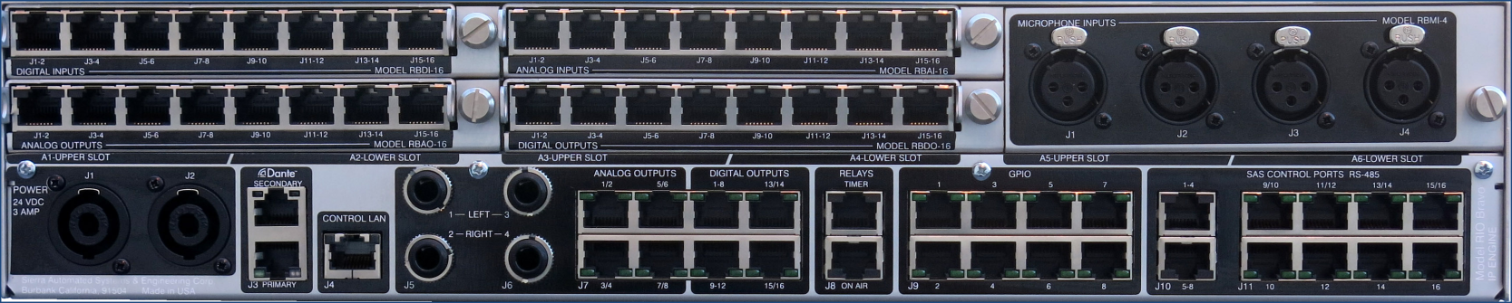

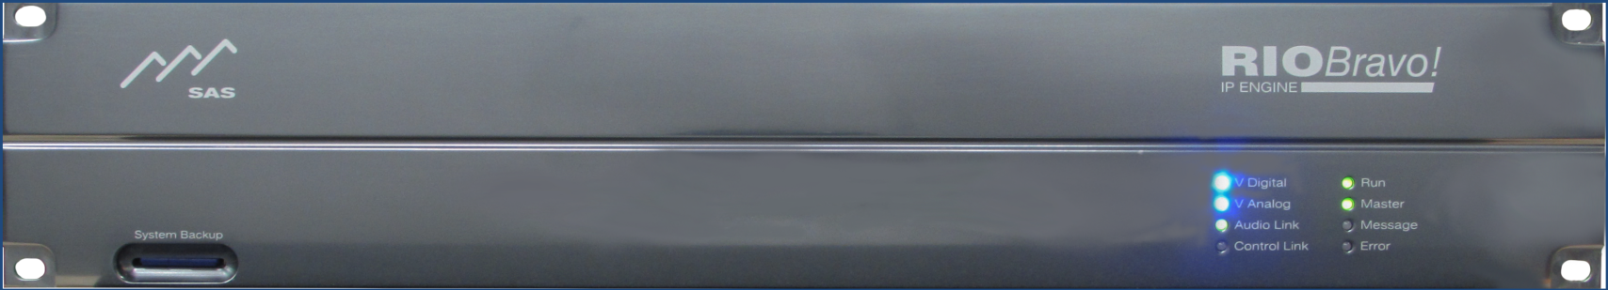

**User Guide- Preliminary**

Table of Contents

Preface 3

Overview 4

Features: 4

Front Panel 5

Rear Panel 6

Getting Started 7

Network Configuration 9

RIO Bravo Local System Configuration 10

Input Channel Configuration 12

Output Channel Configuration 15

Web User Interface 17

SYSCFG.TXT 17

Glossary 18

Appendix A: Support and Limited Warranty 19

**Table of Figures**

Figure 1: RIO Bravo Overview 4

Figure 2: RIO Bravo Front Panel 5

Figure 3: RIO Bravo Rear Panel 6

Figure 4: RIO Bravo I/O Plugin Modules 6

Figure 5: Rear Panel Power and Control Connections 7

Figure 6: SYSCFG File 7

Figure 7: Web Interface Access 8

Figure 8: RIO Bravo Web Server Menu 8

Figure 9: Network Config Screen 9

Figure 10: Local System Setup 10

Figure 11: RIO Bravo Configuration 10

Figure 12: Edit User Slot Configuration 11

Figure 13: User Menu 12

Figure 14: Input Channel Configuration 12

Figure 15: Input Channel Assignment 13

Figure 16: Input Channel Configuration Views 13

Figure 17: Input Channel Configuration 14

# Preface

Thank you for purchasing an SAS product. We are confident it will meet your requirements and provide years of service. Please check this product and make sure it is the model you ordered. If you need to contact us, please refer to Appendix A: Support and Limited Warranty.

**Proprietary Notice**

This document contains proprietary information, which may not be disclosed to others or used in manufacturing, or any other purpose, without written permission from Sierra Automated Systems & Engineering Corporation. The information and design disclosed herein were originated by and are the property of Sierra Automated Systems & Engineering Corporation. All patent, proprietary design, manufacturing, reproduction, use and sales rights are reserved except where those rights are expressly granted to others.

**Copyright Notice**

Copyright 2017 by Sierra Automated Systems & Engineering Corporation, Burbank, California, USA. All rights reserved. Reproduction in whole or in part without prior written permission from Sierra Automated Systems & Engineering Corporation is prohibited.

**Limited Warranty**

This product RIO Bravo IP Engine of Sierra Automated Systems & Engineering Corporation (SAS) is warranted to be free from defects in materials and workmanship for a period of one year from the date of sale (see Support and Other Information for details.)

**User Guide Revision**

This RIO Bravo IP Engine User Guide is published by the Engineering Department of Sierra Automated Systems & Engineering Corporation, which is responsible for its contents. SAS reserves the right to revise this publication and to make changes in the content hereof without obligation to notify any person or organization of such revisions or changes

# Overview

The RIO BRAVO IP Engine is a fully integrated DSP based engine from SAS. The high capacity small footprint engine is designed to fit in any control room and provides all functions necessary for Radio Broadcast operations. The RIO Bravo provides you with direct Ethernet connectivity. You can now control your SAS 32KD system using an internet web browser interface while maintaining compatibility with the traditional SAS Router

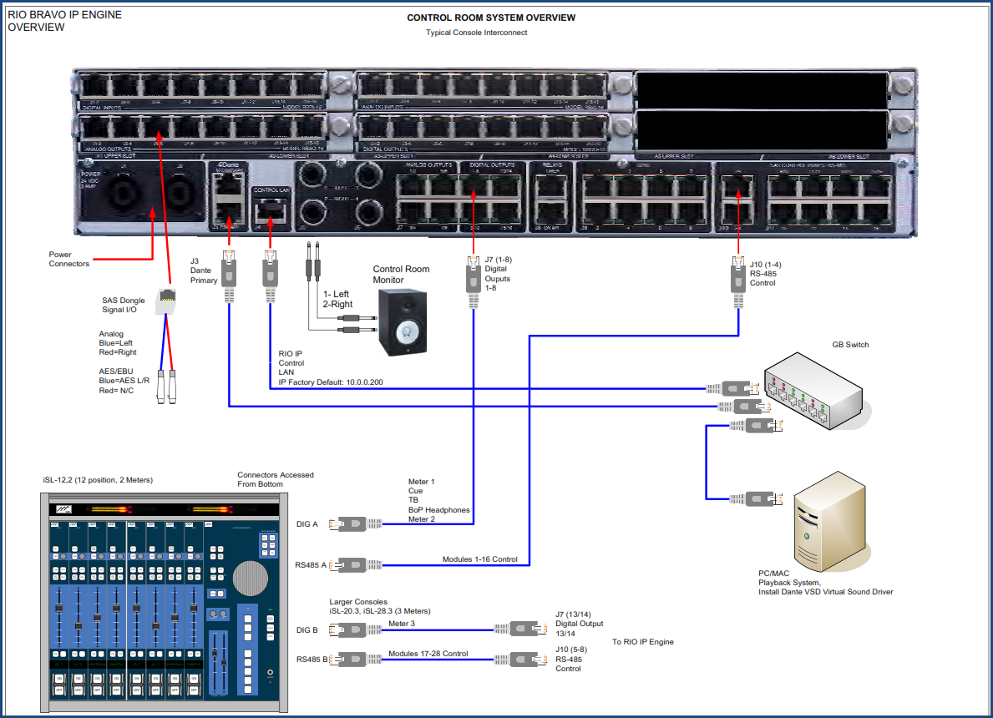

Figure 1: RIO Bravo Overview

## Features:

* Fully Integrated DSP Mixing IP Engine, up to 92 separate mixes
* On-board 8 discrete analog channels (4 stereo) and 16 discrete digital channels (8 AES).
* Up to 96 discrete I/O ports configured in 6 slots
* Dual Dante AoIP ports with built in switch for network redundancy.
* 5 embedded High Power DSP engines
* EQ, Effects, Silence Sense, and Peak Detection.
* Web Based User Interface for control and configuration
* Fully integrated Automation for control room and show control.
* Redundant Power Connectors
* 2 sets of TRJ jacks for audio monitoring

## Front Panel

The 2RU aluminum front panel is polished and anodized gun metal blue. Indicator lights as follows:

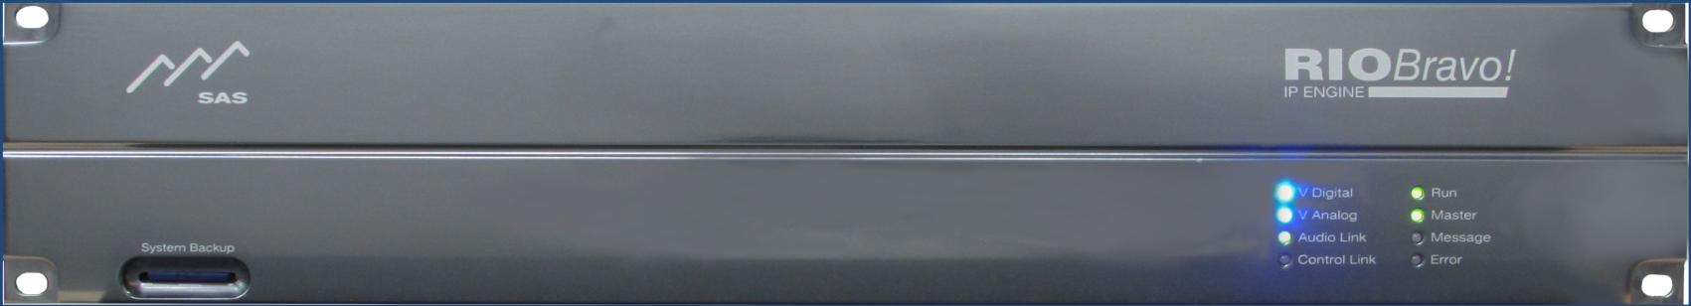

Figure 2: RIO Bravo Front Panel

**System Backup** provides an SD card for saving and restoring frame system data and specifying initial IP address information

**V Digital** indicator is solid blue when powering digital devices.

**V Analog** indicator is solid blue when powering analog devices.

**Audio Link** is solid green when Dante’s Ethernet is working and red when it is not.

**Control Link** light blinks green when engine is connected to the network.

**Run** light flashes green when engine is running.

**Master** light is solid green when engine operates single or when providing master clock with multiple engines.

**Message** light blinks green when a message is received over the link.

**Error** light blinks red when the RIO encounters an error.

## Rear Panel

All installation and configuration devices for the RIO Bravo are located in the rear panel (see Figure 3):

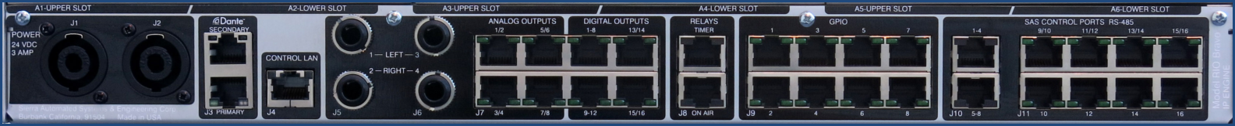

Figure 3: RIO Bravo Rear Panel

**J1 & J2 POWER:** two connectors for feeding redundant power (+24 VDC) from SAS power supply.

**J3 Dante PRIMARY & SECONDARY:** dual RJ45 for connection to Dante AoIP network.

**CONTROL LAN J4:** for connection to your control network.

**J5 1(L)/2(R) & J6 3(L)/4(R):** two stereo 1/4” jacksfor connection to monitoring devices. *Note,TRS jacks in parallel with RJ45 1-4: J5-1 (L) to J7-1; J5-2 (R) to J7-2; J6-1 (L) to J7-3; and J6-2 (R) to J7-4.*

**J7 1–8 ANALOG OUTPUTS:** four RJ45 for connection to eight discrete analog outputs or four stereo. These connectors also provide +12V DC that can power head phone amps. *Note TRS jacks in parallel with RJ45 1-4: J5-1 (L) to J7-1; J5-2 (R) to J7-2; J6-1 (L) to J7-3; and J6-2 (R) to J7-4.*

**J7 1–16 DIGITAL OUTPUTS:** four RJ45 for connection to 16 discrete digital outputs or eight AES outputs   
(4 AES outputs on first RJ45, 2 AES on next and 1 AES on two connectors). Digital Outputs 1-8 often used to feed console meters, cue, talkback, and headphones.

**J8 RELAYS:** Two RJ45 for connection to a Timer (Relay 9=Stop, Relay 10=Run, Relay 11=Reset)

and a studio On Air light (Relay 12).

**J9 GPIO 1 - 8:** Eight RJ45 for connecting 8 relays out and logic in. Use these GPIO for reading external switches, driving indicators, and other control functions in your studio. Relay on pins 1 & 2. Logic In close pin 7 to 8.

**J10 SAS CONTROL PORTS 1 - 8:**  2 RJ45 for connecting eight RS-485 control ports. You can connect a console with up to 16 modules per RJ45 (up to 32 slots using both connectors).

**J11 CONTROL PORTS 9 – 16:** 8 RJ45 for connecting to eight RS-485 ports. Use these to connect any SAS controller including console modules. You can connect up to 4 controllers per port.

**A1 – A6 SLOT**: for connecting up to six I/O plugin modules (sold separately). Available modules provide   
16 discrete analog or digital channels. Figure 4: Model RBAI-16 provides 8 Stereo (16 Mono) Analog Inputs; Model RBDI-16 provides 8 AES3 (16 Mono); Model RBAO-16 provides 8 Stereo (16 Mono) Analog Outputs: and the RBDO-16 provides 8 AES3 (16 Mono) outputs.

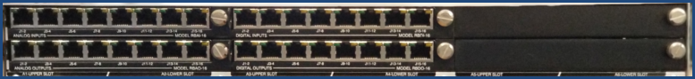

Figure 4: RIO Bravo I/O Plugin Modules

# Getting Started

1. Connect power cord supplied by SAS to either RIO Bravo’s J1 or J2 connectors. Connect to both when using redundant power supplies. Figure 5 below shows power cord connected to J1.
2. You should see the following lights on the front panel: V Digital, V Analog, Audio Link, Run, and Master. You should also see the following lights on the rear panel: J3, J4, J7 Analog 1 – 8, and J11 Control Ports 9 – 16.
3. Connect RIO Bravo to your IP network using “CONTROL LAN J4” connector.

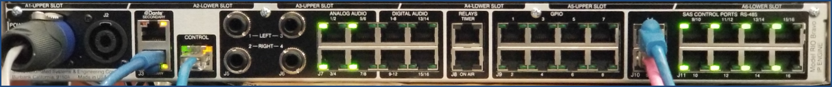

Figure 5: Rear Panel Power and Control Connections

1. Once you have successfully connected your RIO Bravo to the network, you’ll need to know its temporary IP address in order to access the web server for programming and configuration. There will be a tag with the IP address attached to the unit’s front panel. You can also find the IP address in the “SYSCFG.TXT” file, which is contained on the SD card. Remove the SD card from the “System Backup” slot in the front panel and use an SD card reader/writer to open and view its contents. The ‘SYSCFG.TXT” file should look like the one in Figure 6 below.

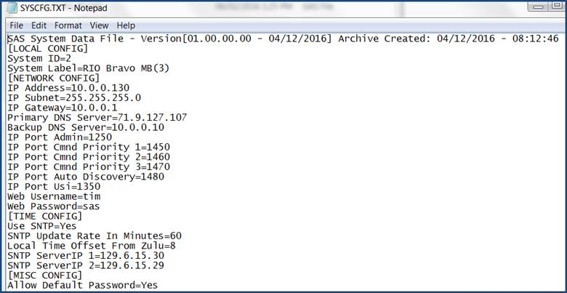

Figure 6: SYSCFG File

1. Open your web browser and type IP address. In our example, this address is 10.0.0.130.
2. Enter Username and Password and click Submit. In our example we are using the default username: **SASDefault** and password: **sas** as shown in Figure 7 below. *Note that you won’t see the password on your screen. Also note that you can change both Username and Password if needed.*

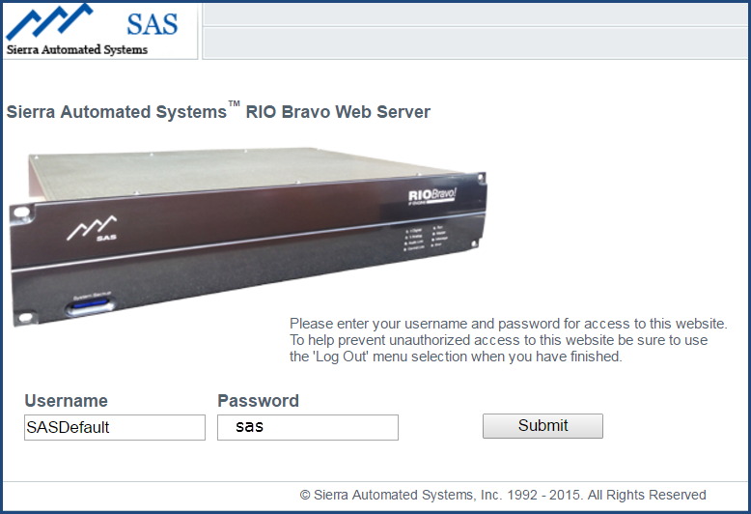

Figure 7: Web Interface Access

1. If you have successfully logged in you should see the screen shown in Figure 8.

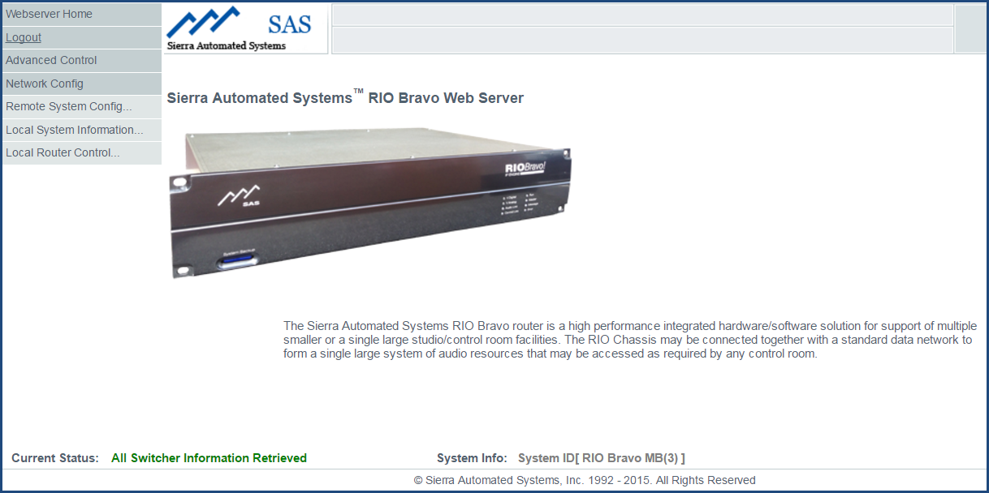

Figure 8: RIO Bravo Web Server Menu

1. Notice the grayed items in the upper left. We will refer to these as the **User Menu.** We’ll briefly describe Network Config and Local System Information and describe Local Router Control in more detail.

## Network Configuration

Choose the **Network Config** tab to obtain a window similar to Figure 9 below. Here you can change any network settings in your system. Be sure to press the Send button to send your changes through the system.

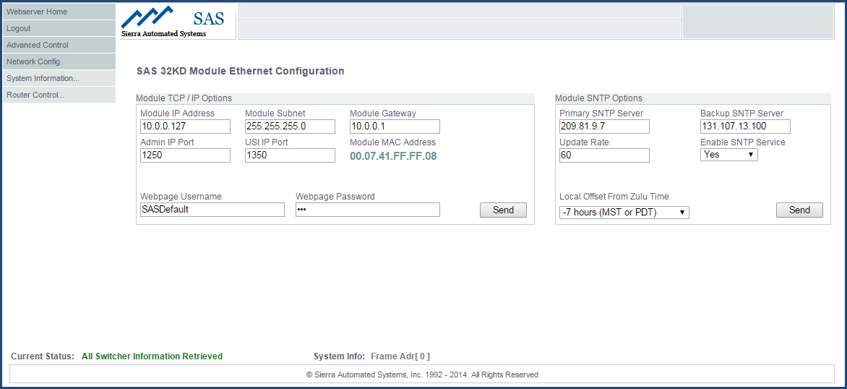

Figure 9: Network Config Screen

# ****RIO Bravo Local System Configuration****

In most instances your RIO Bravo will be pre-configured at SAS. However, if you need to make any changes, follow the procedure below:

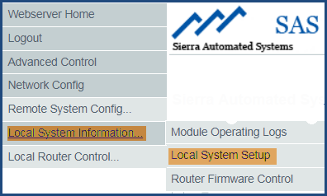

Figure 10: Local System Setup

1. As shown in Figure 10, select **Local System Information** and then click **Local System Setup**. You’ll get a graphic representation of the I/O modules installed in your RIO Bravo (see Figure 11).

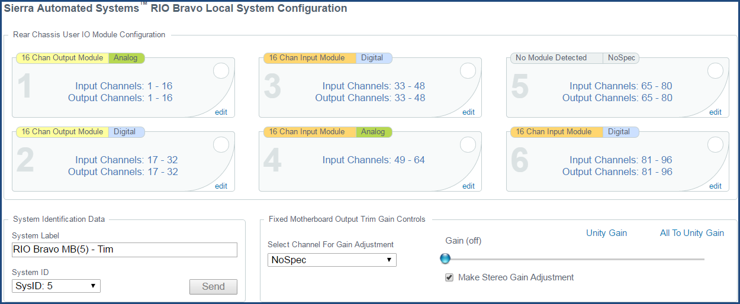

Figure 11: RIO Bravo Configuration

1. Click the **edit** button at the right-hand corner of each module to make the following changes:

A. Assignment of channel numbers to I/O modules. Typically SAS will set the first Input to number 001 and the first Output to 001, and then increment to each of the next installed modules.

B. Adjust Input and/or Output Gain for each channel.

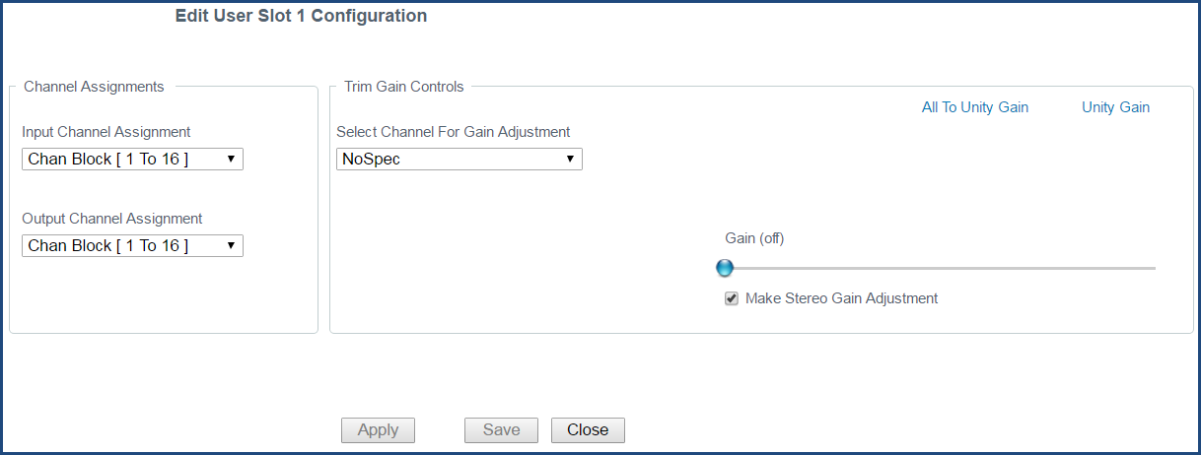

Figure 12: Edit User Slot Configuration

# Input Channel Configuration

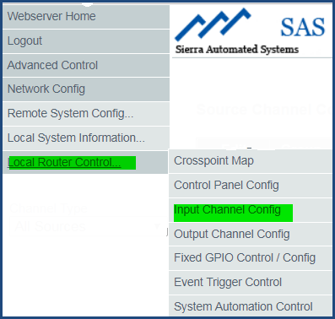

Figure 13: User Menu

From User Menu (shown in Figure 12), click **Local Router Control** and then select **Input Channel Config** to get a table similar to Figure 13 below:

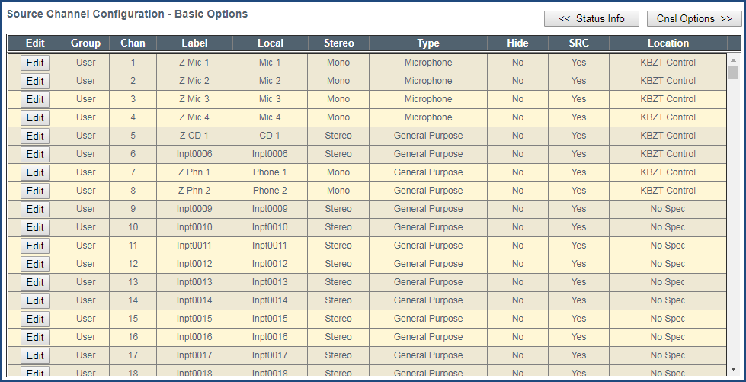

Figure 14: Input Channel Configuration

There are four types of Input Channels available to the user:

224 User - 92 Mix Bus - 64 Network - 64 Effect

You can choose the Type of Input displayed from **Channel Type** drop down or by scrolling down the table. These are shown under the column labeled **Group**:

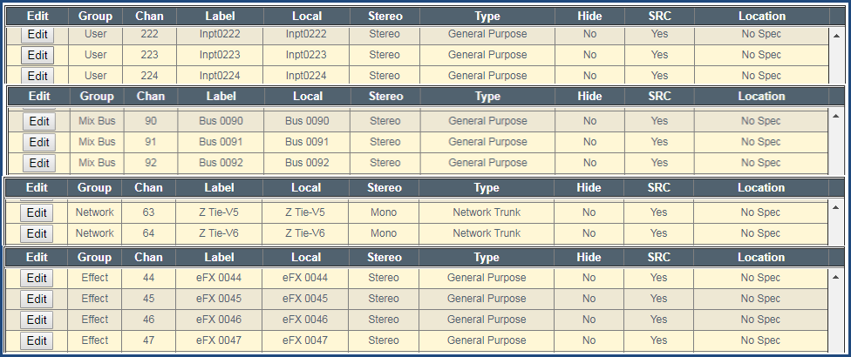

Figure 15: Input Channel Assignment

Note that you can get seven different views of your input channel configurations by clicking either of the two top buttons (see yellow highlight in Figure 16): Basic Options, Console Options, GPI Options, GPO Options, Silence Detect Info, Peak Detect Info, and Channel Status Info

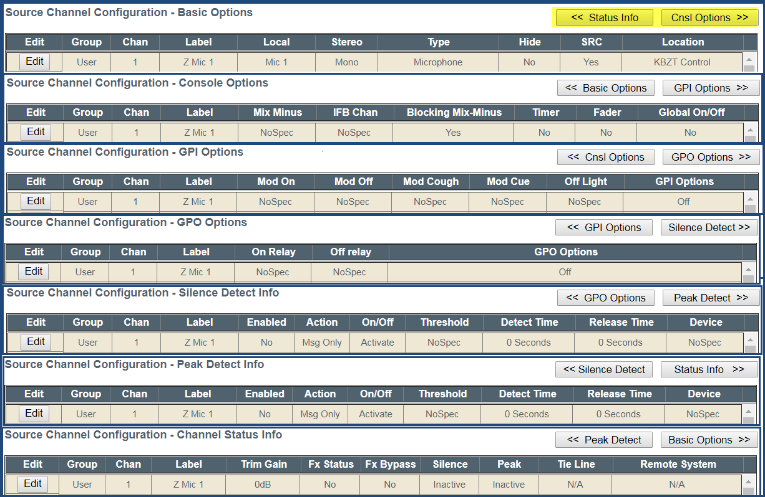Figure 16: Input Channel Configuration Views

Clicking the Edit button on the any input channel will provide you with the Input Channel Configuration window shown in Figure 17. TIP:*Hovering your mouse pointer over any entry box will display important user information.*

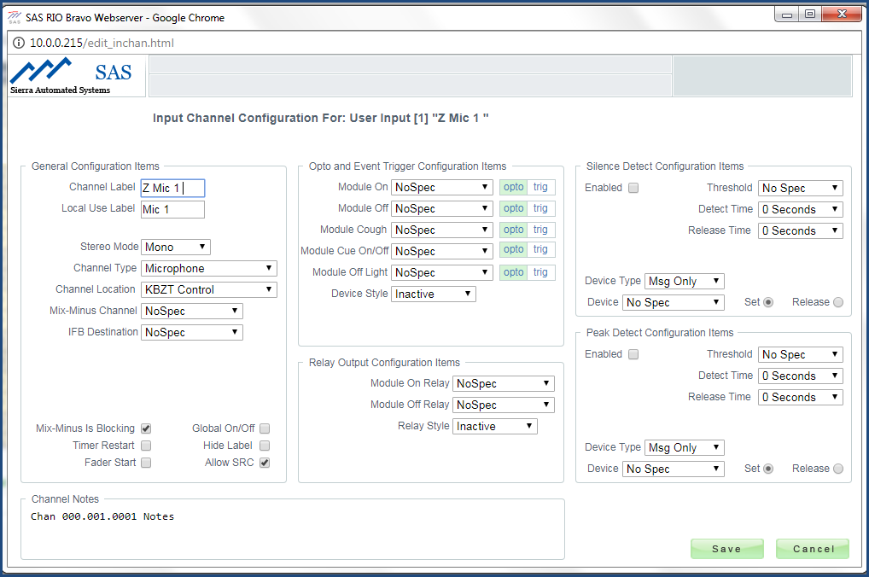

Figure 17: Input Channel Configuration

# Output Channel Configuration

Select **Output Channel Config** from Local Router Control tab to get a table similar to Figure 18.

System Example

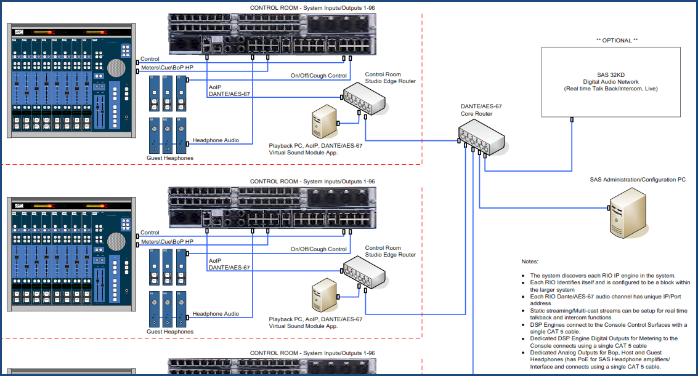

# Web User Interface

Web browsers currently tested compatible are:

1. Microsoft Internet Explorer, version 11

2. Google Chrome, version 41.xx

3. Firefox, version 21.xx

4. Safari, version 5.1.7

# SYSCFG.TXT

**For any change to take effect you must restart the RIO Bravo engine.** This can be accomplished by cycling the power or clicking on Restart from the System Update page on the web browser interface.

1. Modify the IP address and other parameters as needed to work with your IP network and save the file. ***Caution****: do not change MAC Address under any circumstances!*
2. Install the SD card into the slot on the RIO Bravo front panel and restart if changes were made. The IP address is only established with a Restart.
3. When Power is applied to the RIO Bravo both blue Power lights will come on initially. After 10 to 15 seconds the unit will being to operate and the Run light will blink green.

# Glossary

Input:

Source:

Output:

Destination:

# Appendix A: Support and Limited Warranty

Customers can contact Sierra Automated Systems & Engineering Corporation (SAS):

Phone: 818-840-6749

Fax: 818-840-6751

Website: <http://www.sasaudio.com/>

Our business hours are Monday through Friday, from 9am to 6pm Pacific Time. If you need to contact us after hours for emergency support, call us at (818) 840-6749 - please leave a message if you do not get an answer and we will be contacted.

If your SAS product needs to be returned to the factory, contact us to obtain an RA number.

SAS is located at 2821 Burton Avenue, Burbank, California 91504. Before you contact us about support or returns, please have the following ready:

• Model number of the product (ex: RIO Bravo)

• Serial Number (s/n number printed on a silver label)

**Limited Warranty**

The product RIO Bravo of Sierra Automated Systems & Engineering Corporation is warranted to be free from defects in materials and workmanship for a period of one year from the date of sale. Sierra Automated Systems & Engineering Corporation’s sole obligation during the warranty period is to provide, without charge, parts and labor necessary to remedy covered defects appearing in products returned prepaid to Sierra Automated Systems & Engineering Corporation, 2821 Burton Avenue, Burbank, California, 91504, U.S.A.

This warranty does not cover any defect, malfunction or failure caused beyond the control of Sierra Automated Systems & Engineering Corporation, including unreasonable or negligent operation, abuse, accident, failure to follow instructions in the Technical Manual, Owner's Manual or User Guide, defective or improper associated equipment, attempts at modification and repair not authorized by Sierra Automated Systems & Engineering Corporation, and shipping damage. Products with their serial numbers removed or effaced are not covered by this warranty.

This warranty is the sole and exclusive express warranty given with respect to Sierra Automated Systems & Engineering Corporation products. It is the responsibility of the user to determine before purchase that this product is suitable for the user's intended purpose.

Any and all implied warranties, including the implied warranty of merchantability are limited to the duration of this express limited warranty. Sierra Automated Systems & Engineering Corporation is not liable for incidental or consequential damages of any kind.